Pumpkin tart [21cm tart mould]
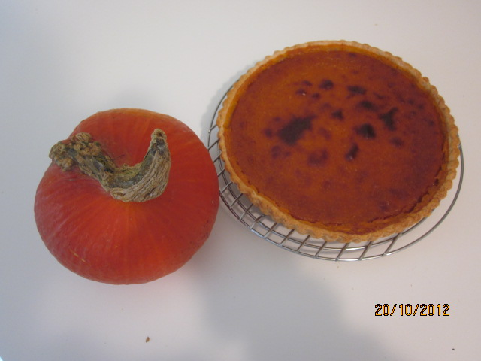

Ingredient :

Pie sheet 1 role
Pumpkin (type of ORANGE) 300g without skin and seeds
Egg yolks 3
Sugar 70g
Salt 1/4 teaspoon (small)
Cinnamon (cannelle) powder 3/4 teaspoon
Ginger powder 1/4 teaspoon
Clove (girofle) powder 1/4 teaspoon
Fresh cream 80 ml
Milk 50ml

- Lay the pie sheet into the mould -> keep it in the fridge.
- Skin the pumpkin off and take the seeds out -> cut into big pieces
- Steam the pumpkin until they get soft.
- Mash the soft hot pumpkin in a bowl and mix it with the rest of the ingredien (from egg yolks to milk).
- Pour the pumpkin mixture into the mould.
- Bake it 20-25 mins (or more) in the preheated oven at temperature 200 c.

Serve with softly whippied cream

