GYO-ZA (Dumpling)
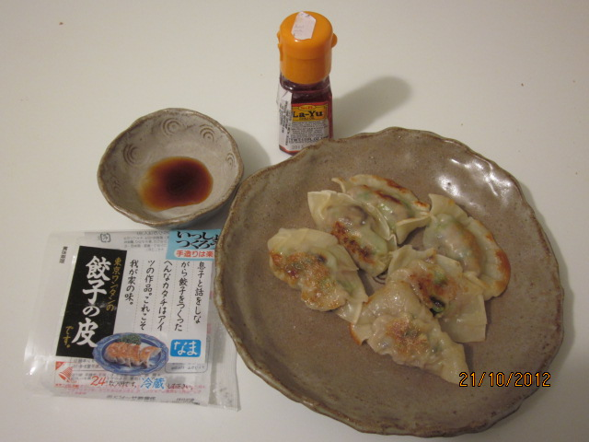

Ingredients(for 24 pieces = 1 packet of Gyoza Sheets):

Minced meat (normally pork) 250g
Chinese cabbage or cabbage 300g(3 sheets)
Spring onion (chopped in to pieces) 1 piece
*Gyo-za sheet 1 packet
Salt 1/2 teaspoon (small)
Soy sauce (sho-yu) 1+1/2 tablespoon (big)
Pepper (kosho) little bit
Juice of ginger 1 teaspoon
(= only juice from the grated ginger)
Sake (Japanese rice wine or sherry) 2 tablespoon
Sesame oil (goma abura) 1 tablespoon
Oil 1 tablespoon

- Boil the Chinese cabbage or the cabbage in the hot water for 3 mins and
Chopped it in small pieces then squeeze it to get rid of the excessive water.

- Mix the minced meat, salt, soy sauce and pepper in a bowl with a hand until the meat mixture gets a bit sticky.

- Add the chopped cabbage (1) into the meat-mix(2), followed by the juice of ginger, sake, sesame oil and the chopped spring onion.
To wrap the ingredient with the gyoza sheet

Little of water can be a glue!

Option 1 : use the pie wrapper or gyoza wrapper

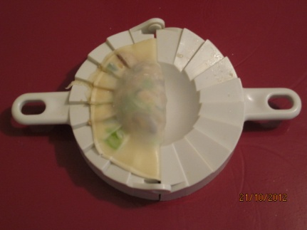
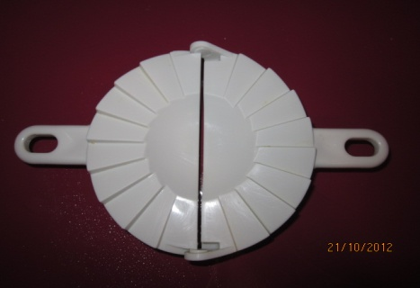
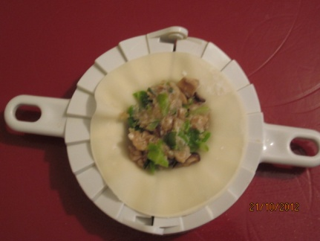
Option 2 : by hand
- Put a gyoza sheet on the one of your hand and dump the half circle of the sheet with water using a finger on your hand free.
- Put the ingredient (not too much!) in the middle of the sheet and fold the sheet to make a half circle shape. Then tuck the edge little by little.

To fry the gyoza

- Warm up a frying pan and put the oil. Then lay the wrapped gyoza in it.
- Fry them on the middle fire until they get light brown.
- Pour the hot water to cover up to the half height of the gyozas and cover the pan with a lid. Steam & fry them on the middle fire for a couple of minutes.
- Uncover the pan and fry to get rid of all the water quickly on the strong fire. Turn the fire back to the middle and fry the gyoza to get the crunchy surface.
Serve with the mixed sauce of little of vinegar, soy sauce and chili pepper oil(ra-yu).

